
PeopleSoft 8.9/PeoplePortal
Job Data Upload Training

Introduction to Job Data Upload 2
Job Data Upload Process 2
Prepare File 2
1. Supervisor Changes Upload 2
2. Payrate Changes Upload 3
3. Shift Changes Upload 4
4. Department Changes Upload 5
5. Terminations Upload 6
6. Business Title Upload 7
7. Status Change Upload 7
8. FCLM Change Upload 8
9. Location Changes Upload 9
10. LOA/RFL Upload 9
11. Paygroup Upload 10
Load process in PeoplePortal 11
Appendix A (FAQ) 16

Introduction to Job Data Upload

Job Data Upload Tool is a self service process which gives users of the PeoplePortal, who have been given the appropriate permissions, the ability to bulk load Job Data Changes at their convenience.
There are five types of Job Data Changes this tool supports
- Supervisor Change
- Payrate Change
- Shift Change
- Department Change
- Terminations
- Business Title Change
- Status Change
- FCLM Update

Depending on the Job Load Type selected , the instruction on the page is displayed which helps you prepare the upload file.

Job Data Upload Process

Prepare File

Supervisor Changes Upload

Using this Upload you can upload the Manager Changes both for employees or Contingent workers. You should be specifying the correct Employee Record Number (Empl Rcd#) for this to happen.
You would not be able to upload Supervisor changes for employees in Terminated Status or for Supervisor id in terminated status.
Each upload file should be a comma separated file (.csv file) with the fields in the order shown below. The best way to create the file is to start with the pre-designed template which can be downloaded here:
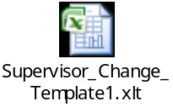
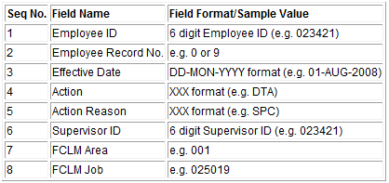
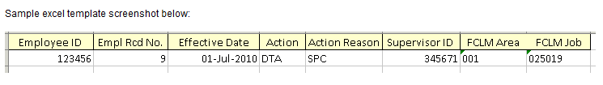

Payrate Changes Upload

Using this Upload, you can upload Pay Rate Changes for both Contingent Workers and Employees.
You should be using the Empl ID (not the payroll id) and the correct Empl Rcd# for the load to succeed.
If you are uploading any other Job Data Changes for the same effective date, please be sure to upload the Payrate Change file only after uploading the others(e.g Department Change Upload).

Each upload file should be a comma separated file (.csv file) with the fields in the order shown below.The best way to create the file is to start with the pre-designed template which can be downloaded here:
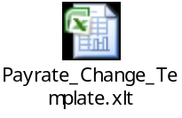

Please refer the document attached for the Valid Action reason for the Action Pay Rate Change (PAY).
https://inside.amazon.com/en-us/Libraries/docs/public/Documentation_Action_Reason_Codes.xls
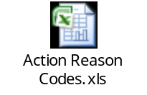

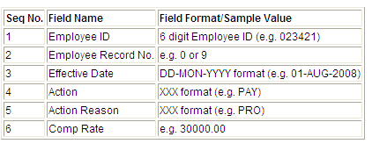

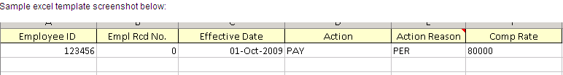

Shift Changes Upload

Using this Upload you can upload both Shift Pattern or Shift Differential (ADP Shift) at a time or separately.
Each upload file should be a comma separated file (.csv file) with the fields in the order shown below.The best way to create the file is to start with the pre-designed template which can be downloaded here:
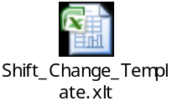
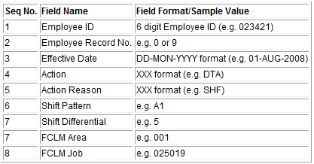

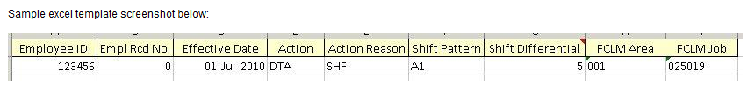

Note: Shift Differential requires the code, not the actual amount. Current values as of October 5th are listed below. Reference spreadsheet can be found here for this and other code translations.

CODE | DESCR
~ | 0
2 | 0.25
7 | 0.5
8 | 0.65
5 | 0.75
3 | 1
4 | 1.25
6 | 1.5
1 | 1.65
A | 1.75
B | 2
9 | 2.5
E | 2.65
F | 2.75
J | 2.85
G | 3
D | 3.25
H | 3.5
M | 3.75
O | 4.25
P | 4.5
Q | 4.75
R | 5

Department Changes Upload

Using this Upload you can upload the Cost Center Changes for both Contingent workers and Employees.

Each upload file should be a comma separated file (.csv file) with the fields in the order shown below.The best way to create the file is to start with the pre-designed template which can be downloaded here:
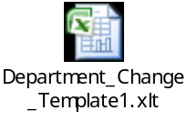

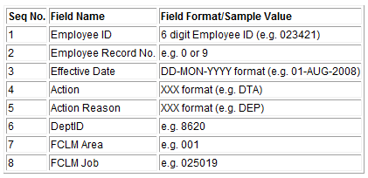

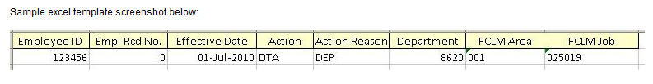

If the department you are uploading is not enabled for the business unit of the person, send us the request to enable it at hris@amazon.com

Terminations Upload

Terminations Upload in Peak Q4 will help you save time. Please be sure to pick correct Action/Action Reason depending on whether you are terminating a Contingent Worker or Employee paid by Amazon.

- For Contingent Workers Always use Completion/End of Assignment. Please be sure that you are not keying Completion for OBA associates by error as this would trigger termination of account immediately.

- For Employees use Termination with End Temporary Employement or Voluntary/Involuntary Action Reason. It is necessary to specify the Term Reason and Primary Factor for Voluntary/Involuntary terminations.

Each upload file should be a comma separated file (.csv file) with the fields in the order shown below.The best way to create the file is to start with the pre-designed template which can be downloaded here:
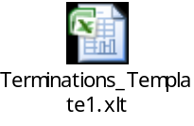
Please refer the below link for the Termination Reasons and Factors.
https://inside.amazon.com/en-us/Libraries/docs/public/Documentation_Termination_Reasons_and_Factors.xls

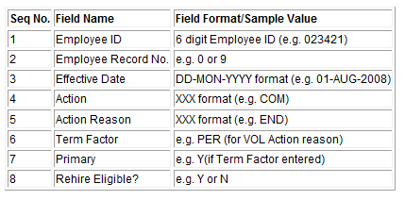

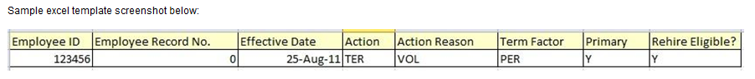

Business Title Upload

Using this Upload you can upload Business Title
Each upload file should be a comma separated file (.csv file) with the fields in the order shown below.The best way to create the file is to start with the pre-designed template which can be downloaded here:

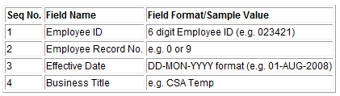

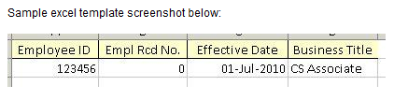

Status Change Upload

Using this Upload you can upload status changes.
WARNING: Status Changes may affect an employee’s Paid Time off Accruals, Benefits and stock grant (s). Please notify the Payroll, Benefits and Stock departments.
Each upload file should be a comma separated file (.csv file) with the fields in the order shown below.The best way to create the file is to start with the pre-designed template which can be downloaded here:
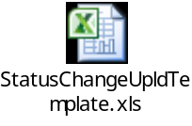
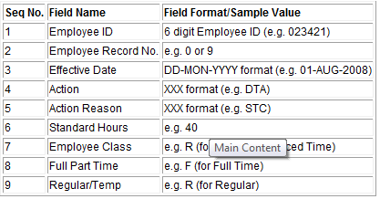

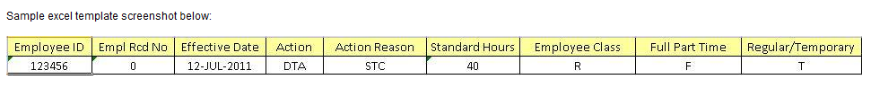

Note: For Employee Class code & Full Part Time code, please refer spreadsheet here and for other code translations.

FCLM Change Upload

Using this Upload you can upload FCLM Change
Each upload file should be a comma separated file (.csv file) with the fields in the order shown below.The best way to create the file is to start with the pre-designed template which can be downloaded here:
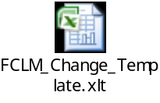
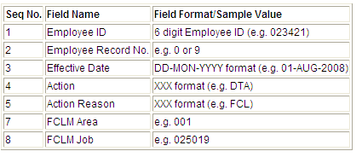

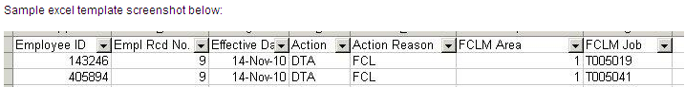

Location Changes Upload

Using this Upload you can upload the Location Changes both for employees or Contingent workers. You should be specifying the correct Employee Record Number (Empl Rcd#) for this to happen.
You would not be able to upload Location changes for employees in Terminated Status or if location is inactive.
Each upload file should be a comma separated file (.csv file) with the fields in the order shown below. The best way to create the file is to start with the pre-designed template which can be downloaded here:
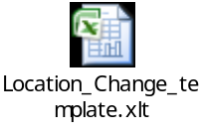
Seq No. | Field Name | Field Format/Sample Value
1 | Employee ID | 6 digit Employee ID (e.g. 023421)
2 | Employee Record No. | e.g. 0 or 9
3 | Effective Date | DD-MON-YYYY format (e.g. 01-AUG-2008)
4 | Action | XXX format (e.g. DTA)
5 | Action Reason | XXX format (e.g. LOC)
6 | Location | 3 digit Location code (e.g. 116,002,055 etc)

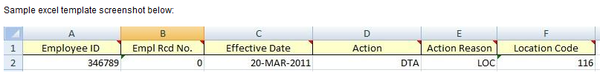

LOA/RFL Upload

Using this Upload you can upload the LOA and RFL Changes both for employees or Contingent workers. You should be specifying the correct Employee Record Number (Empl Rcd#) for this to happen.
You would not be able to upload LOA and RFL changes for employees in Terminated or other than Germany employees.
The Effective date mentioned here in case of RFL is the Last day of LOA. So when the upload happens system automatically increases the effective date by +1. For Eg: The employee Last day of Leave is 07-Dec-2011, in the input file please give 07-Dec-2011, system will enter a row with Action RFL with Effdt as 08-Dec-2011
Each upload file should be a comma separated file (.csv file) with the fields in the order shown below. The best way to create the file is to start with the pre-designed template which can be downloaded here:
Fehler! Keine gültige Verknüpfung.

Seq No. | Field Name | Field Format/Sample Value
1 | Employee ID | 6 digit Employee ID (e.g. 023421)
2 | Employee Record No. | e.g. 0 or 9
3 | Effective Date | DD-MON-YYYY format (e.g. 01-AUG-2008)
4 | Action | XXX format (e.g. LOA)
5 | Action Reason | XXX format (e.g. PRS)

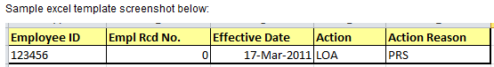

Paygroup Upload

Using this Upload you can upload Paygroup. The fields required should be in the below format.
Seq No. | Field Name | Field Format/Sample Value
1 | Employee ID | 6 digit Employee ID (e.g. 023421)
2 | Employee Record No. | e.g. 0 or 9
3 | Effective Date | DD-MON-YYYY format (e.g. 01-AUG-2008)
4 | Action | XXX format (e.g. DTA)
5 | Action Reason | XXX format (e.g. LOC)
6 | Paygroup | XXX format (e.g. DEF)
7 | Employee Type | e.g. S(For Salaried)
8 | Comprate | e.g. 30000.00
9 | Comp Frequency | e.g. A (For Annual)

Each upload file should be a comma separated file (.csv file) with the fields in the order shown below.The best way to create the file is to start with the pre-designed template which can be downloaded here:
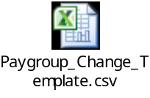
Sample Excel Screenshot:

Important Notes when preparing the data for load:

- You would be able to upload data only for employees for whom you are able to enter data in the online Job Data component. (e.g. you will not be able to do Job Data Changes Upload as you are also not able to do that in the online component. Also, if you do not have access to enter data for HR folks online in the Job Data component, you will not be able to upload data for them via this tool either.)

- Once the Upload is complete, there is no way to roll back the Changes. So please be sure that you are uploading the correct data in correct format.(e.g If you have uploaded Supervisor Change for incorrect supervisor id, you would have to manually go to Job Data and correct the row as you would not be able to upload another Supervisor Change row for the same effective date)

- Data is loaded in Update/Display mode. So the tool will not be able to load historical rows.

- You would not be able to upload Job Data Changes for Employees in Terminated status.

- Use the downloadable excel templates to prepare data. If you want to copy and paste data into this template, DO NOT overwrite the formatting of the columns in the template. The way to do this is by using the “Paste Special” instead of Paste function. To use Paste Special do the following:

  - Copy the data from the source spreadsheet as you normally would.
  - Then right-click on the top left cell just below the header row on the template (A2).
  - Select “Paste Special” from the menu that will open.
  - On the Paste Special dialog box, select “Values” and then click “OK”.

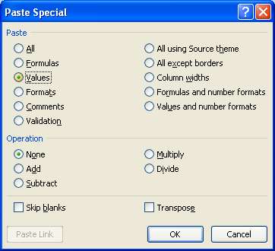

- Once you have prepared the data save the file as a csv file by doing the following

- Click on File -> Save As.
- Choose CSV(Comma delimited) (*.csv) option for “Save as type:”
- Give appropriate name in “File Name:” edit box.
- You may get the Microsoft excel warning shown below. Click OK.

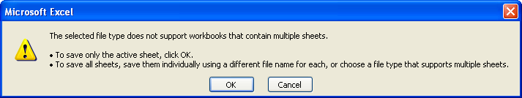

- You will get another Microsoft Excel warning shown below. Click Yes.

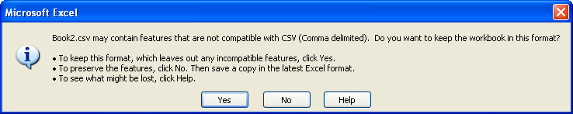

- Your load file is now created and ready to be uploaded to the PeoplePortal.

Load process in PeoplePortal
- Navigate to Data Upload -> Job Data Upload.

- You will see the following screen.

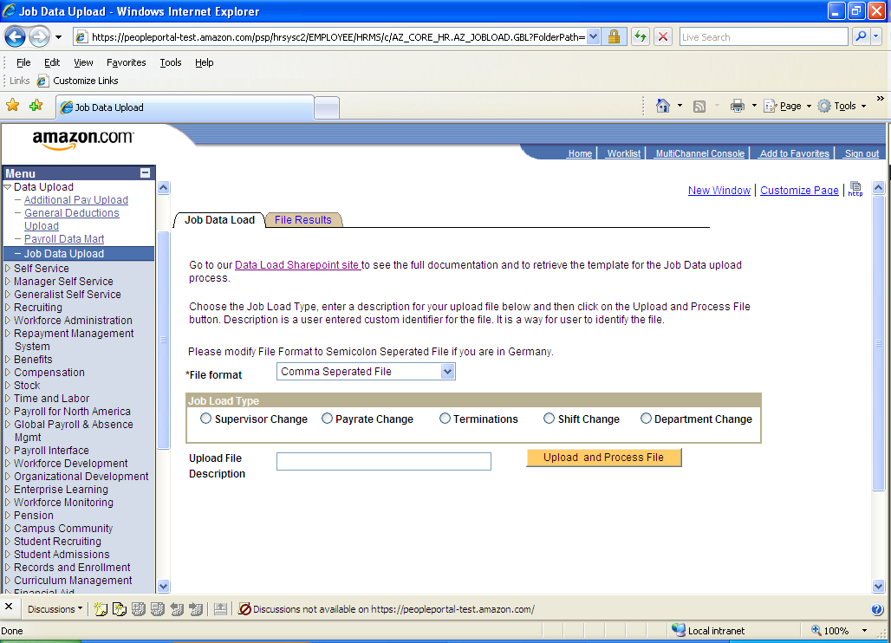

- Pick up the Job Load Type

- Enter the description of the upload file (e.g. Pay Rate Change Sep 2009). This can be any name you like. It’s purpose is to give you an easy way to remember the file. It will be one of the searchable fields you can use to find file results for past data loads.

- Next click on the “Upload and Process File” button.

- This will bring up the File Dialog box. Click the “Browse” button to select the file on your local computer which you want to upload. This is where you select your previously prepared .csv file from your local machine.

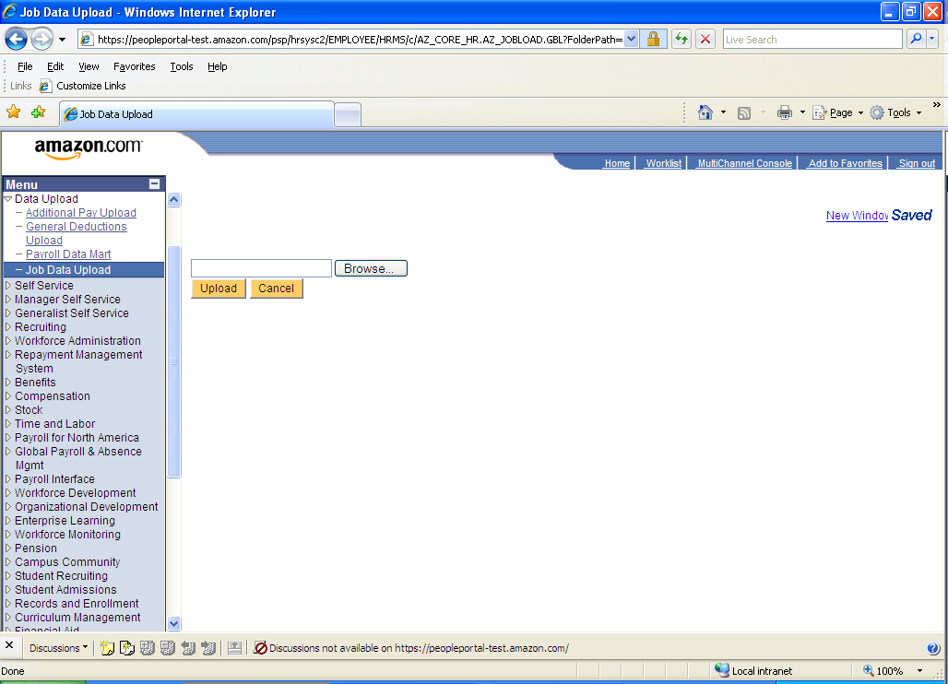

- Once the file is chosen click on the Upload button. This will upload the file to the PeoplePortal server for processing. You will see the following message after clicking the Upload button.

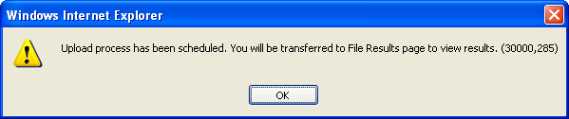

- Click OK. Then as the message says, you will be transferred to the File Results tab to view results of your load.

- Initially you would see the following screen with the message that the upload is being processed.

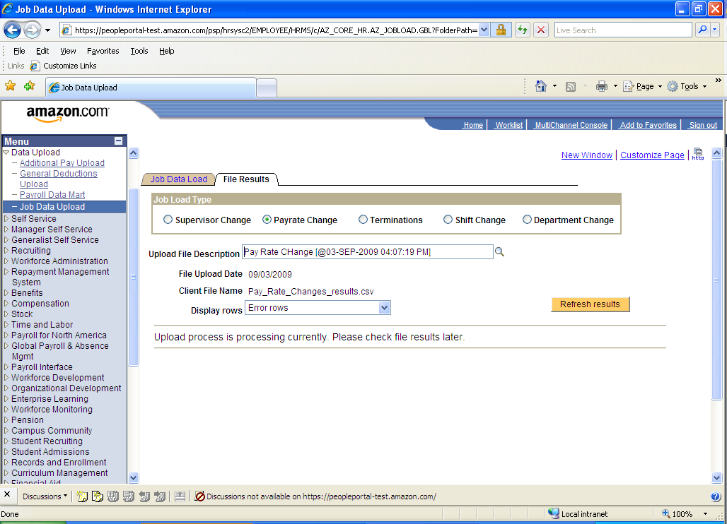

- It may take several minutes for the upload process to finish, depending on the amount of data to be uploaded. You can click on Refresh results button to check if the process has finished uploading the file.

- Once the process has finished, the File Results page would show results as below:
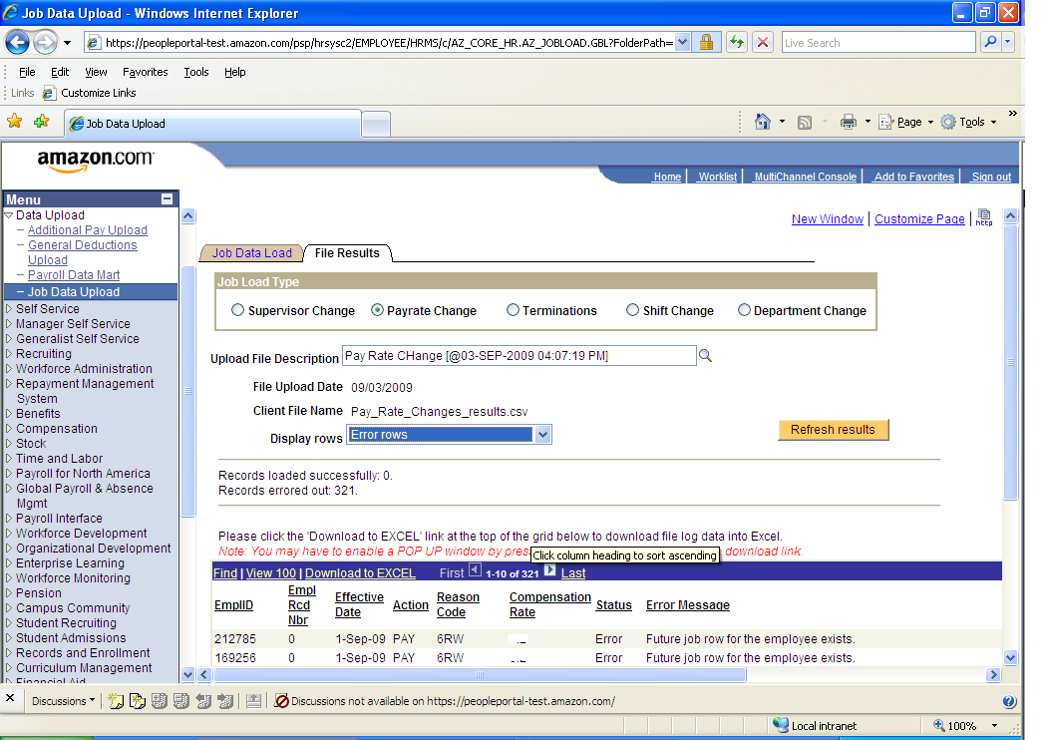

By default, Display rows is set to Error rows, so the grid shows the rows from input file which have errored along with the error message. You can change the Display rows dropdown to All rows or Successful rows as well. Doing so will filter the grid as selected.

By default, when you come to the File Results page it shows the results for the last file which you uploaded based on the Job Load type picked. You can also choose previous files which have been uploaded by selecting a different file from the Upload File Description prompt (click on the magnifying glass). Upon selecting the new file the results of the chosen file would be shown on the grid.

There is a Download to EXCEL functionality available in the link of the grid header. By clicking on this link you can download the grid data into excel. Users can use this feature to download the grid data (Error rows), correct the errors in the data, strip off Status and Error Message columns, save it as a .csv file and use it as an input file to load the rows which errored out in the previous load, following the same procedures as before. (Be careful not to reload successful rows with the error corrections.)

Appendix A (FAQ)

Q. When downloading to excel, I see following error message:

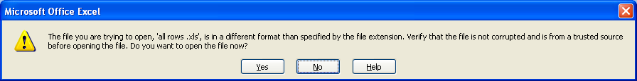

A. If you experience a pop up message/error that you need to click on before downloading grid data to Excel 2007, you can download a Patch to prevent this from happening.

Go to Run Advertised Programs from your Start Menu:

Select: Amazon Excel 07 Fix for PeopleSoft Data - Fix - Excel 07 for PeopleSoft Data

Once you see the notification that the Patch has been applied, you should be set.

Q. I am loading Job Data upload file. I get following error:
Employee Id / Empl Rcd# does not exist or you do not have row level security to view/update employee's record.
A. This error message tells that either the employee id is incorrect in the concerned row or the user uploading the file does not have permission to view the data for the employee. If it is an HR employee for which user gets the above error, user should send rows errored out with the above message to their Location Superuser or erc@amazon.com (for locations supported by ERC) to either hand key or upload the errored rows.

Q. Process is sitting in Processing status for more then an hour. What do I do?
A. Email hris@amazon.com with Upload File description, file upload date and Client File Name to investigate the process.

